15. Write the Python Program to Implement Decision Tree Algorithm
Name:P.Gayathri
Reg.No:192424324

Aim
To implement the Decision Tree Algorithm for classification by building a simple decision tree and predicting the class label based on user input.

Algorithm
Step 1:
Start the program.
Step 2:
Define the decision rules.
Step 3:
Ask the user to enter the weather condition (Sunny/Rainy).
Step 4:
If the weather is Sunny, ask whether the humidity is High or Normal.
Step 5:
If the weather is Rainy, ask whether it is Windy (Yes/No).
Step 6:
Apply the decision tree rules.
Step 7:
Display whether the person should Play or Not Play.
Step 8:
Stop the program.

Code:
# Decision Tree Algorithm (Simple Rule-Based)

print("===== Decision Tree Classification =====")

weather = input("Enter Weather (Sunny/Rainy): ")

if weather.lower() == "sunny":

humidity = input("Enter Humidity (High/Normal): ")

if humidity.lower() == "high":
print("\nDecision: Don't Play")
else:
print("\nDecision: Play")

elif weather.lower() == "rainy":

windy = input("Is it Windy? (Yes/No): ")

if windy.lower() == "yes":
print("\nDecision: Don't Play")
else:
print("\nDecision: Play")

else:
print("\nInvalid Input")
input:
Enter Weather (Sunny/Rainy): Sunny
Enter Humidity (High/Normal): High

OUTPUT:
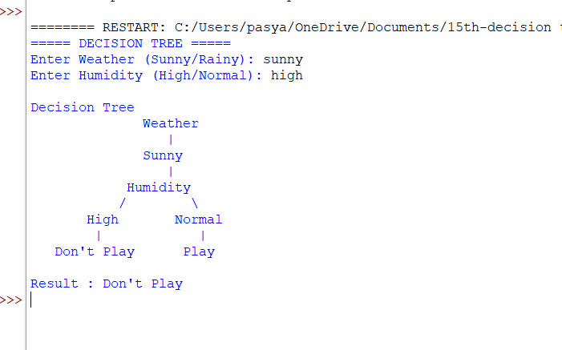

RESULT:
Thus, the Decision Tree Algorithm was implemented successfully in Python, and the decision (Play or Don't Play) was determined based on the given input conditions.

